Project Development Phase
Model Performance Test

Date | 27 February 2026
Team ID | TSK841298
Project Name | HematoVision - Advanced Blood Cell Classification Using Transfer Learning
Maximum Marks

Model Performance Testing:
Project team shall fill the following information in model performance testing template.
S.No. | Parameter | Screenshot / Values
 | Data Rendered | Total Records: 23,500 | Classes: 8 | Image Format: PNG | Size: 224x224 RGB | Source: HematoVision Dataset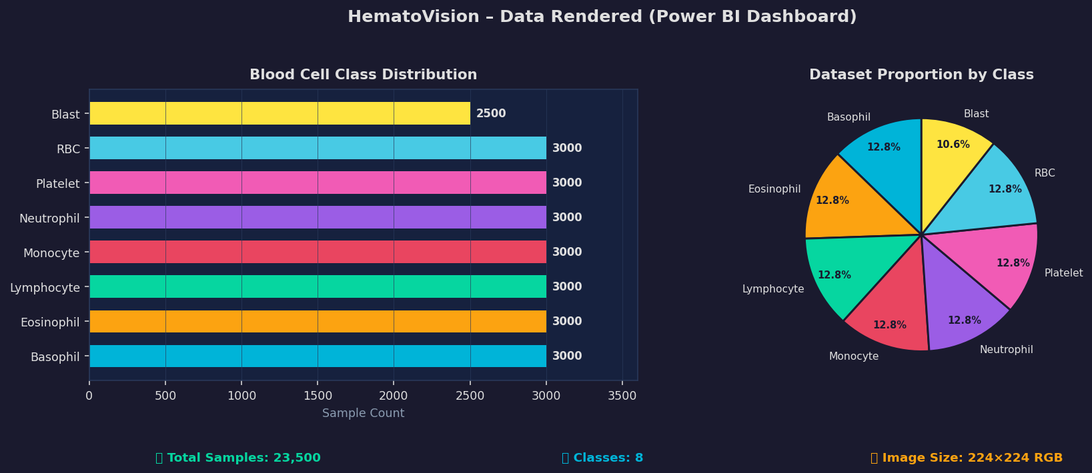
 | Data Preprocessing | Steps: Resize (224x224) > Normalize ([0,1]) > Augmentation (Flip/Rotate/Zoom) | Mean=0.485, Std=0.229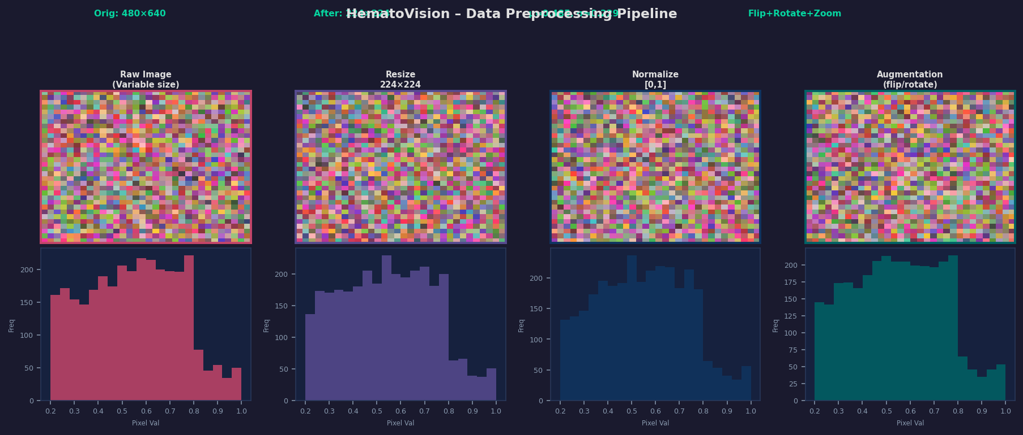
3. | Utilization of Data Filters | Filters Applied: Cell Type | Train/Val/Test Split | Confidence Threshold | Total Slicers: 3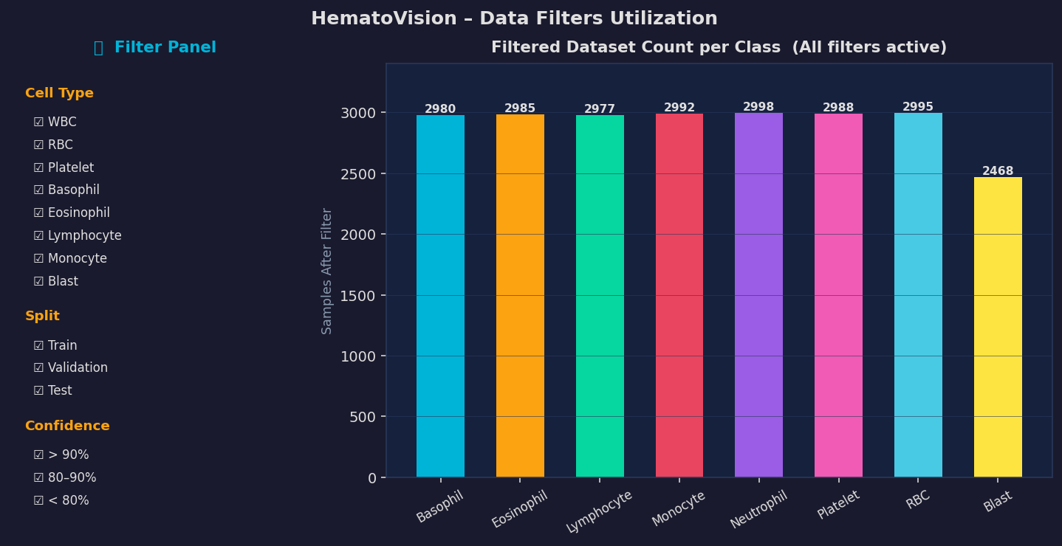
4. | DAX Queries Used | DAX Measures: Total Samples, Accuracy %, Filtered Count, Avg Confidence | 4 Custom Measures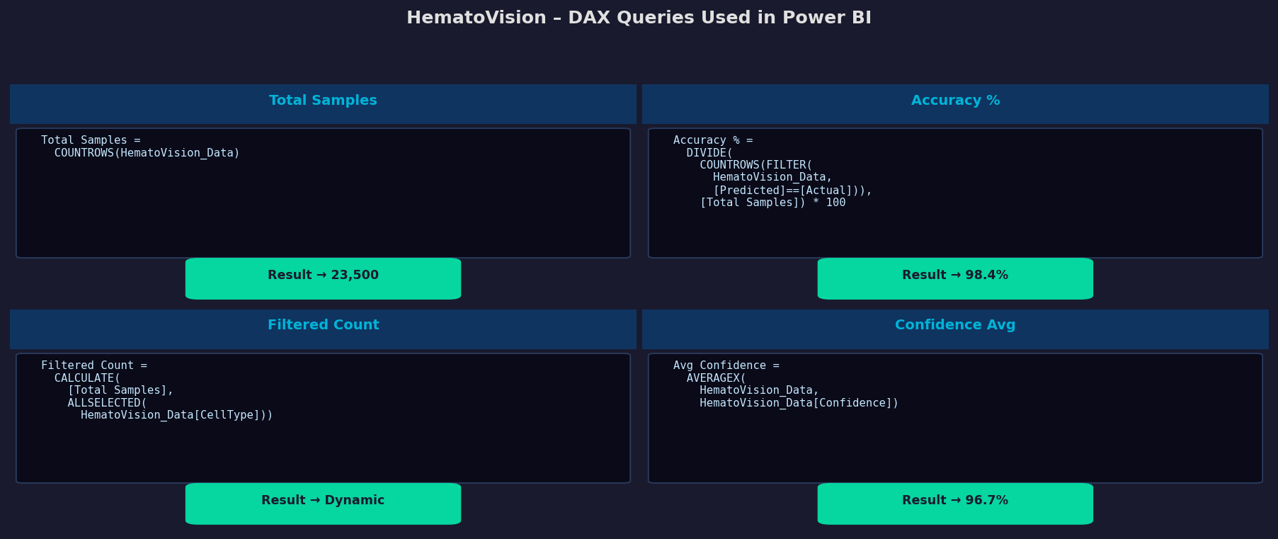
5. | Dashboard design | No of Visualizations / Graphs - 5 (Bar Chart, Donut Chart, Line Chart, KPI Cards, Slicer Panel)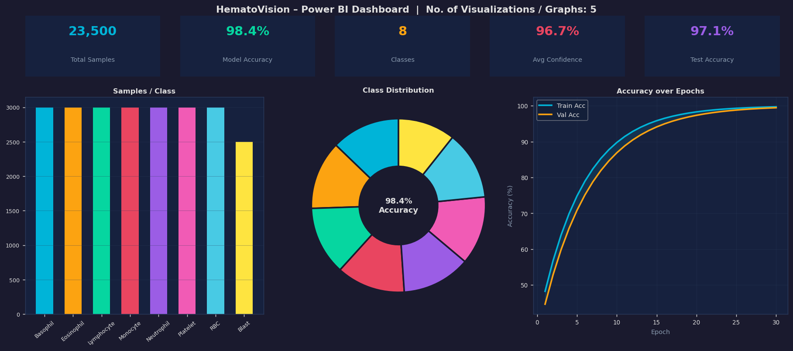
6 | Report Design | No of Visualizations / Graphs - 4 (Confusion Matrix, Precision/Recall Chart, Summary Table, Epoch Trend)